Overcoming Ambivalence through Motivational Interviewing

Filiberto is a 19-year-old Latinx gay male and although he has tested negative three times within the last 9 months, he doesn’t see himself at risk.” He has learned about PrEP, but he doesn’t think he could take it every day. He also is afraid that his family will learn that he is gay if they see him taking it. He has three buddies that he has sex with regularly but has never discussed HIV status with either of them. He is aware that his buddies have other sexual partners besides him, which is the reason he tests frequently.
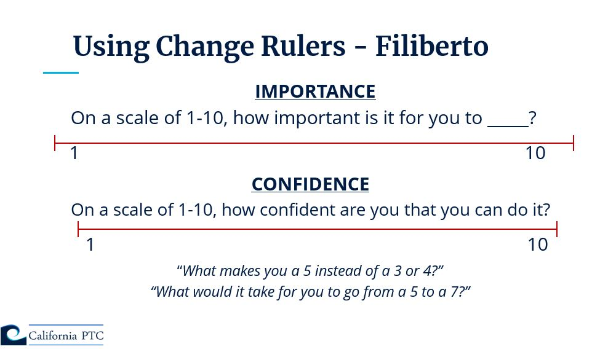
Cecilia is a 34-year-old Latinx transwoman. She has come to your organization seeking PrEP after experiencing a recent HIV exposure, which she had promised herself would never happen again.
When she gets to the front desk the staff person tells Cecilia about an MSM PrEP program that she would be eligible for.
When you come out to the reception area to greet her you see that she has gone, you ask the front desk person about her who responds, “he left, and I don’t know why”
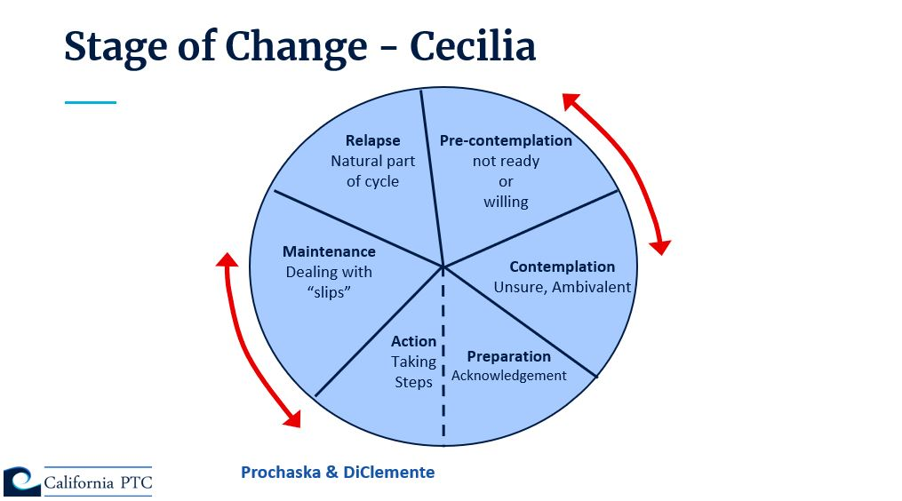

Miguel’s is a 48-year-old gay man. His partner 52-year-old, Vincent is HIV positive has been living with HIV for 30 years. Miguel and Vincent have been in a monogamous relationship for the last 7 years. Vincent has been recently pressuring Miguel to have condomless sex. Miguel has always used condoms with all his partners regardless of their HIV status. He remembers the earlier days of HIV and doesn't take any chances when it comes to protecting himself. He wants to please his partner and doesn’t want to lose him.

Benefits of NOT Changing | Benefits of Changing
Costs of Changing | Costs of NOT Changing

